|  |
| --- |
| INFO-3067 |
| Lab 4 : 4x Screenshots |
| Stephen Mahabir : 0646473 |

Screenshot 1

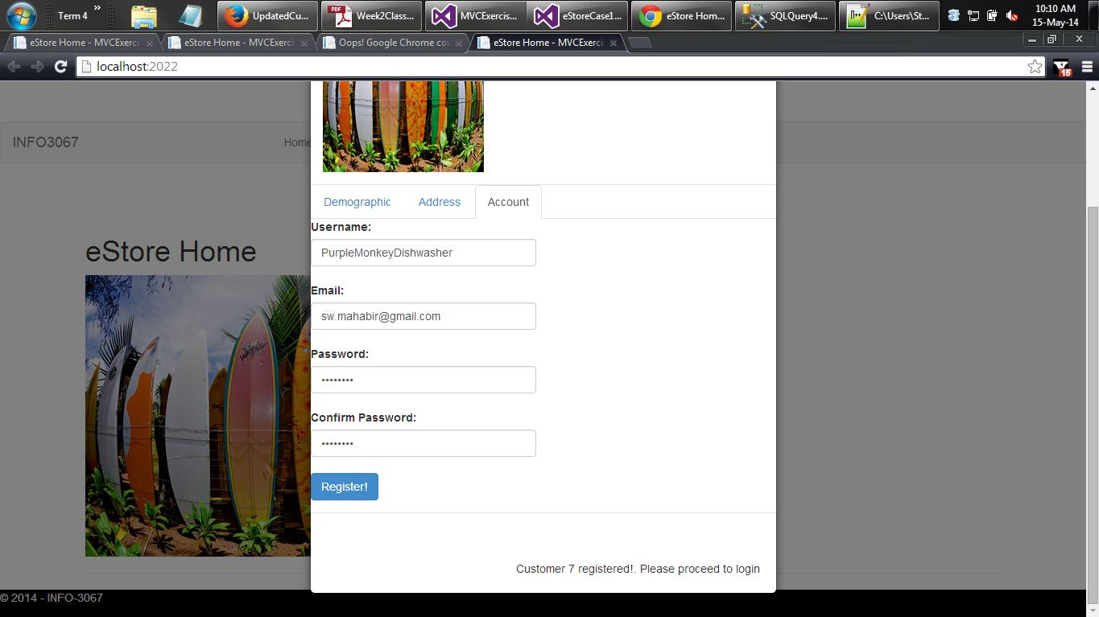

Screenshot 2

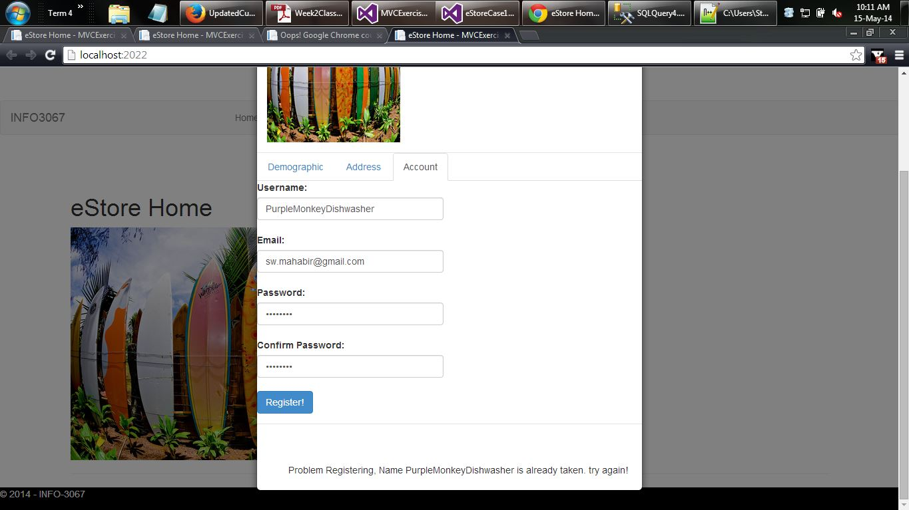

Screenshot 3

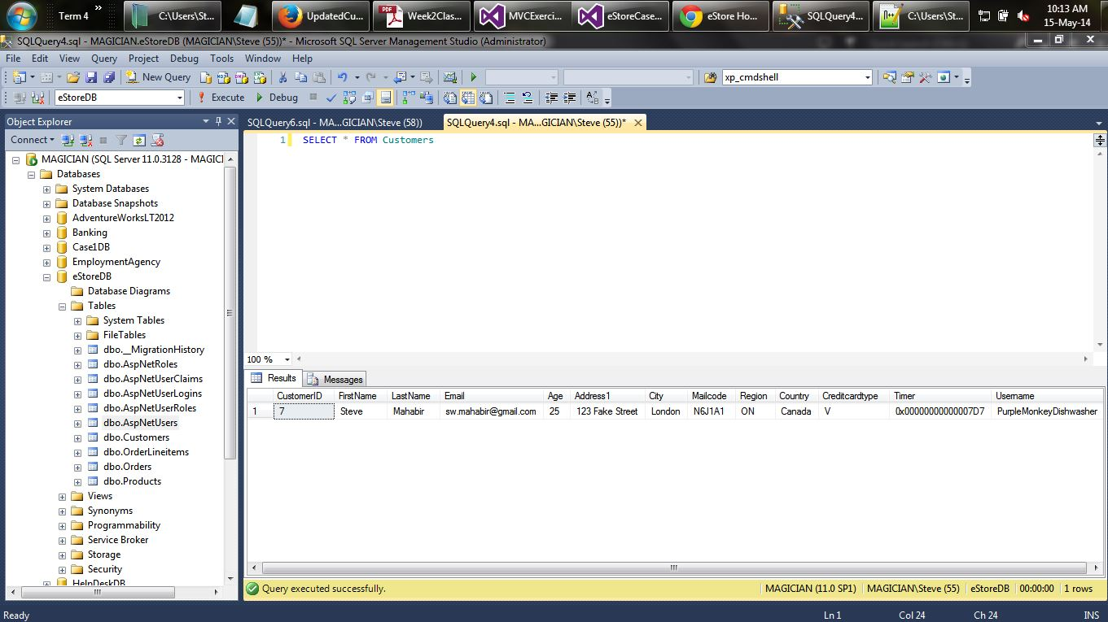

Screenshot 4

